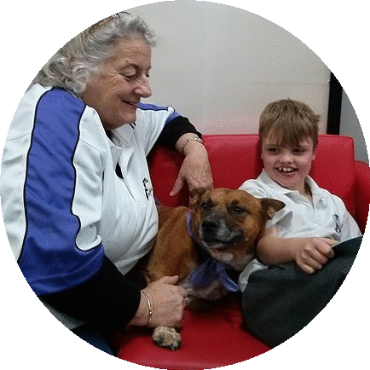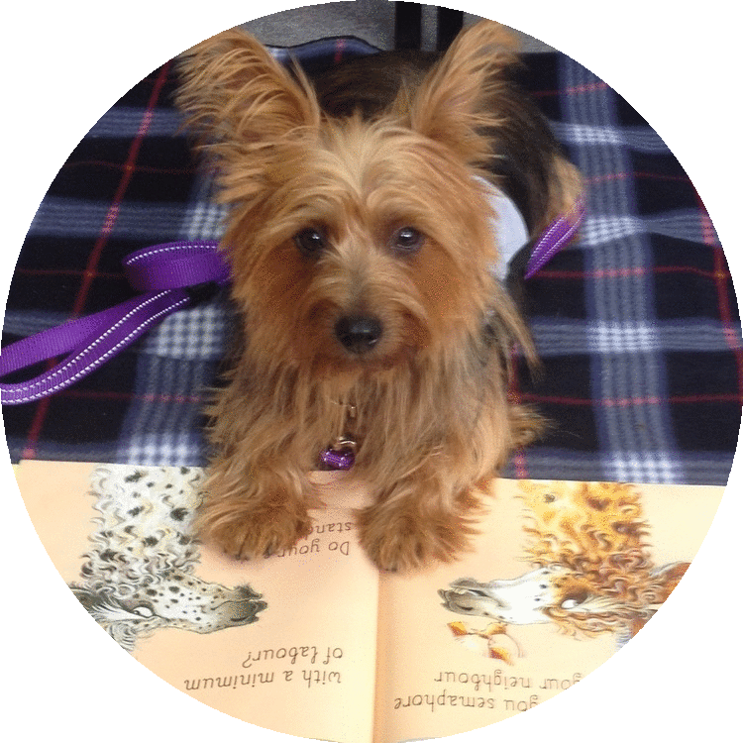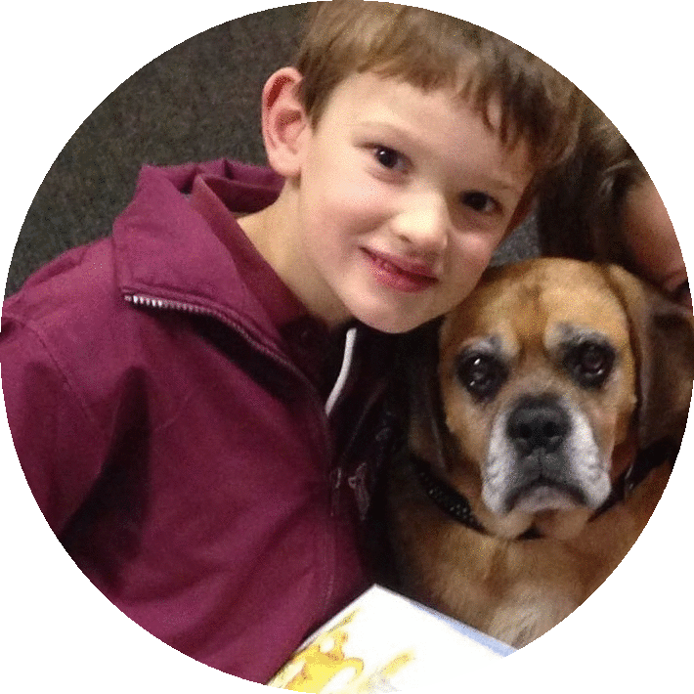



lisa.pawsntales@gmail.com

**How does it work?** reading sessions with a volunteer and their dog are held at participating schools during school term.

Students are selected by the school to participate for a variety of reasons.

**Why does it work?** Bringing a dog and child together to read is a magical experience. Dogs don’t pass judgement or care about a child’s reading levels. They are endlessly caring and loving, don’t point out reading mistakes or become impatient. Above all dogs make reading fun! If reading is fun, children are more likely to practice - and, if they practice they are more likely to succeed. A winning formula! If you would like more information regarding the Paws ‘n’ Tales program in your area please contact

d

For your

**DOGS**

**reading**



**FUN**

**make**

C

**Paws ‘n’ Tales** is a fun and effective reading program which is offered to schools by Paws Pet Therapy for children aged 4-8 with literacy and confidence issues.

Reading to a friendly trained dog and caring volunteer increases confidence, self-esteem & literacy skills in children and helps them to discover a love of books and reading.

**F**

l

h

**www.pawspettherapy.com**

i



