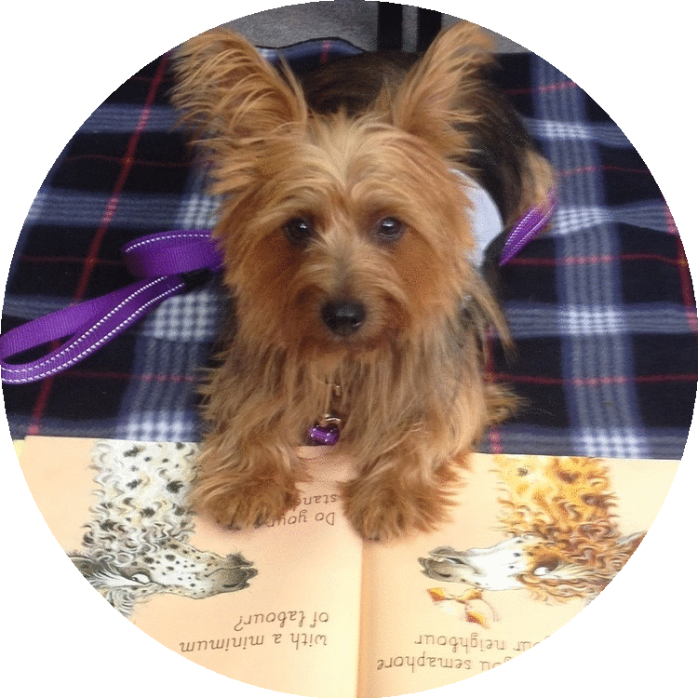

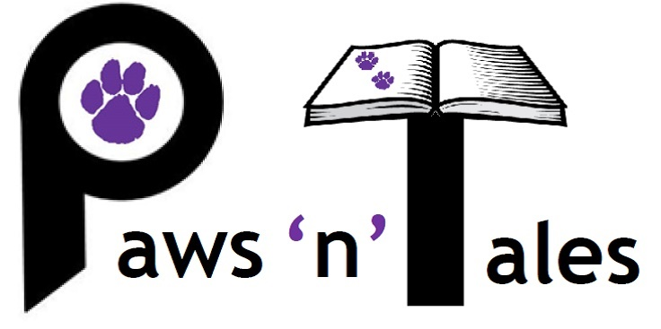



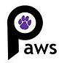

**Pet Therapy**

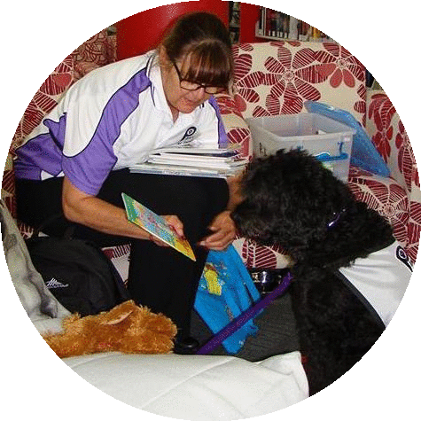

**Paws ‘n’ Tales** is a literacy program that brings volunteers, their loving dogs and children together in schools to make reading fun. It is proudly supported by Paws Pet Therapy, a registered charity with full DGR status.

**What you are giving**

**You are giving the gift of literacy…**

Not being able to read significantly impacts on a child’s school life, their ability to socialise and learn, and dramatically affects their future employment opportunities. For your $500 tax deductable sponsorship you are able to help support a reading team – a trained volunteer and their four-legged best friend in a school - every step of the way.

**What you receive**

**A really great feeling and…**

* The opportunity to be part of a successful literacy solution with the knowledge that you are making a real difference in the life of a child
* A Certificate of Appreciation to display
* Visits where possible from your sponsored team linked to media opportunities
* Your name/logo on the Paws Pet Therapy Website linked to your sponsored team
* A yearly update about the Paws ‘n’ Tales program
* An invoice for taxation purposes

To discuss sponsoring a Paws ‘n’ Tales team please contact lisa.pawsntales@gmail.com

Ommunity Sponsorship

ComS

Dogs make the best reading buddies. They help children relax, love to be patted and demonstrate endless patience

Reading becomes a fun activity that children look forward to

Our dogs don’t make judgements they just listen unconditionally

Our volunteers are caring, professional, fully trained, supported and love what they do









**Why it works**

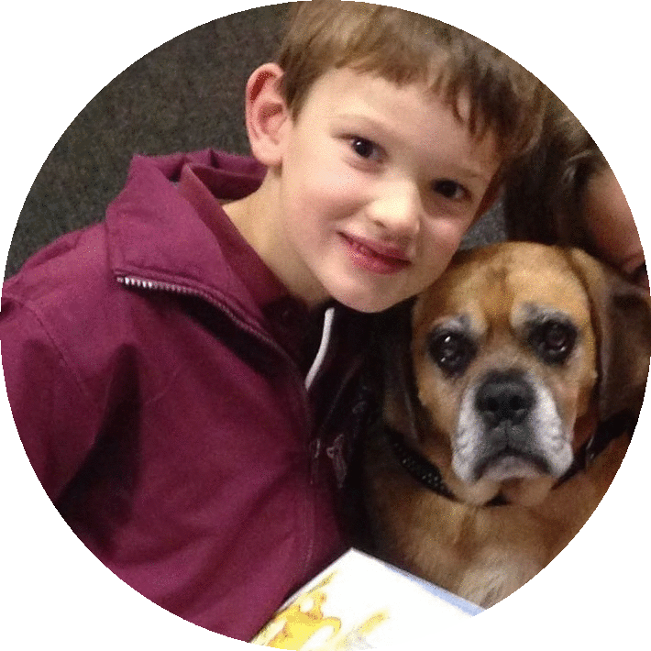

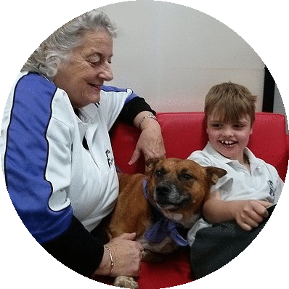

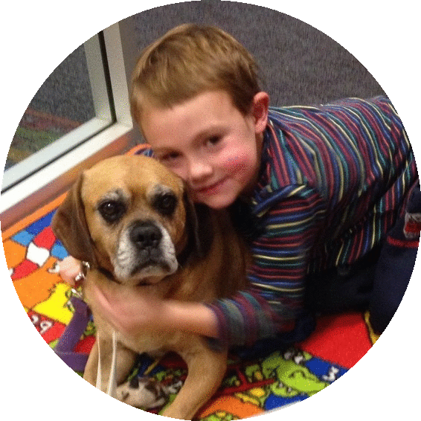

**Children who can read, can learn and succeed**