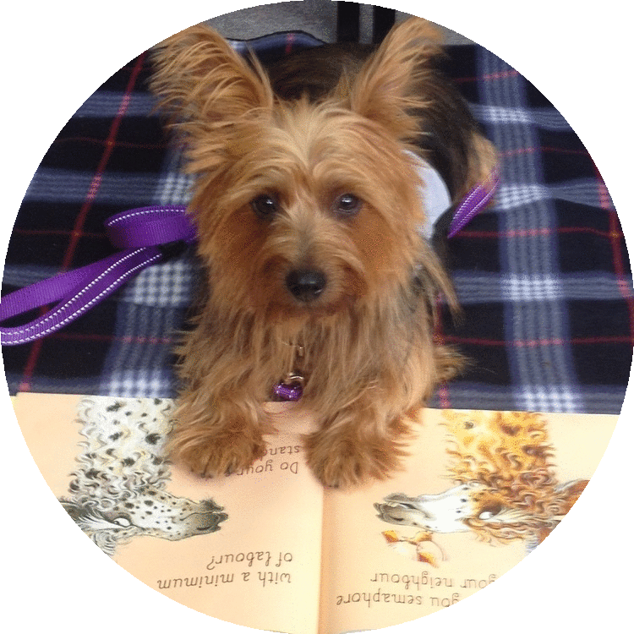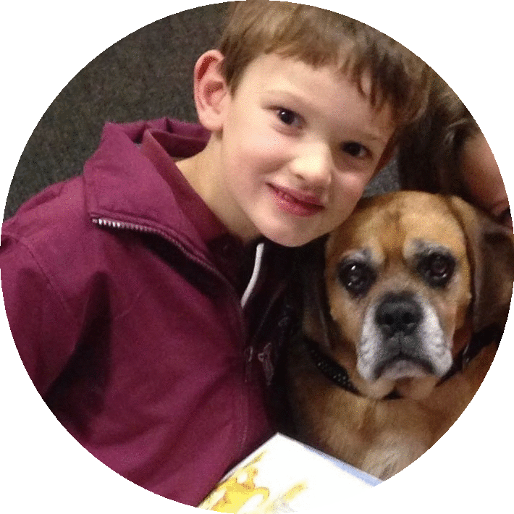



**How does it work?** A fully trained, insured, police, vet and WWC checked team – a volunteer and their loving dog will visit your school weekly to read with children in 1-2-1 sessions, of 15-20 minute duration, flexible to your needs.

**Does it cost anything?** Student participation is **free*.*** However, as it costs $500 to provide a fully insured professional Paws ‘n’ Tales team for a year we will require your support. Options available include fundraising, grants and community or business team sponsorship. For more information please contact

**Paws ‘n’ Tales** is a fun and effective reading program which is offered to schools for children with literacy and confidence issues.

Reading to a friendly trained dog and caring volunteer increases confidence, self-esteem & literacy skills in children and helps them to discover a love of books and reading.

Paws ‘n’ Tales is proudly supported by Paws Pet Therapy a registered charity with full DGR status and is funded by a combination of sponsorship, donation and fundraising.

lisa.pawsntales@gmail.com

**PAWS**

l

h

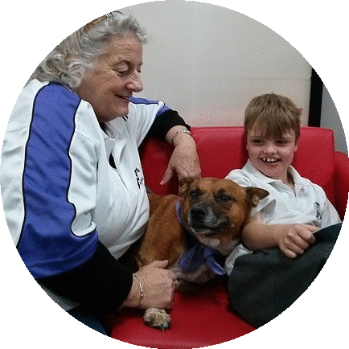

**DOGS**

**READ**

At your

c

**www.pawspettherapy.com**

o

o

S





